Please Check:

Graduate Midwife Registered Nurse

Name of Applicant: _________________________________________ School: __________________________________________

Name and Address of Patient | Case No. | Complete Diagnosis | Date & Time Performed | Full Name, Address of Facility & Contact Number | Supervised by:
 |  |  |  |  | Printed Name & Contact No. | Position/ Designation | Signature | License No./ Expiration Date
1.
2.
3.
4.
5.
6.
7.
8.
9.
10.

(Continued at the Back)

Name and Address of Patient | Case No. | Complete Diagnosis | Date & Time Performed | Full Name, Address of Facility & Contact Number | Supervised by:
 |  |  |  |  | Printed Name & Contact No. | Position/ Designation | Signature | License No./ Expiration  Date
11.
12.
13.
14.
15.
16.
17.
18.
19.
20.

Note: 1) The Clinical Instructor should ensure the competence of the students in the performance of actual deliveries before signing this form.
2) Registered Midwives/Clinical Instructors who supervise Students/Graduate Midwives/Registered Nurses and affix their signature in this Form must present a
Certificate of Training on Expanded Functions of Midwife (R.A. 7392) pursuant to Board Resolution No. 07, Series of 2017, dated September 8, 2017.
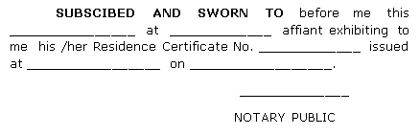
CERTIFIED CORRECT:

Signature: Date:
Printed Name:
Designation: ___________________________
License Number: Expiry Date:

